For Information call: FOR IMMEDIATE RELEASE:
Brian Jackson April 14th, 2023
Junior Achievement
of Oklahoma
918-663-2156
bjackson@jaok.org

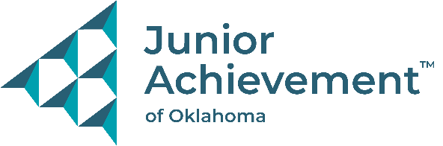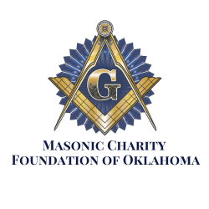

Masonic Charity Foundation of Oklahoma donates $50,000 to Junior Achievement of Oklahoma
Increasing equity through the education and empowerment of Oklahoma’s youth
Oklahoma City, OK- Through a generous $50,000 donation, the Masonic Charity Foundation of Oklahoma has made a substantial investment in Oklahoma’s youth. This benevolent gift will fund multiple Junior Achievement programs such as JA Inspire Exploration Fair (both virtual and on-site), JA Finance Park and JA BizTown. Throughout a four-year relationship with the Masonic Charity Foundation, Junior Achievement of Oklahoma has reached almost 50,000 rural students and shared with them the tenets of fiscal responsibility.
The JA Inspire Exploration Fair, held in both the Tulsa and OKC region, allows JA to aid students in making career-based academic decisions as they prepare to enter high school. Junior Achievement of Oklahoma is excited to continue building the JA Inspire Career Exploration Fair for over 10,000 Oklahoma eighth graders. This Junior Achievement program is the capstone of middle school curriculum and will aid students in making career-based academic decisions as they prepare to enter high school. This JA Inspire Career Fair event offers experiences that will fulfill the ICAP (Individual Career Academic Plan) requirements as set by the state. To fit within the ICAP standards, Junior Achievement will be focusing on recruiting exhibitors from five career clusters or categories: health sciences, communications and IT, manufacturing and engineering, business marketing and management, and human services and resources.
"The Masonic Fraternity is proud to support financial literacy education programs such as those offered by Junior Achievement.", said Glen Chaney, Grand Master of Masons in Oklahoma. "The financial knowledge gained in this program will empower students to make good financial decisions as they begin their adult lives."
About Junior Achievement of Oklahoma
Junior Achievement (JA) of Oklahoma is a business-integrated education partner with expertise in experiential learning that successfully develops key mindsets and skills for students to lead meaningful and successful lives. JA’s high-impact programs drive long-term outcomes in areas of financial literacy, work readiness, and entrepreneurship, and are all delivered by corporate and community volunteers. JA of Oklahoma offers multiple programs, including in-class programs, JA BizTown, JA Inspire, and JA Finance Park. JA of Oklahoma serves over 40,000 students statewide in an average year. JA of Oklahoma has offices in Tulsa and Oklahoma City. For more information, visit jaok.org

